Architecture Document
For Hostel Complaint Management System

1. Application

Selected Architecture: Serverless Architecture
The Hostel Complaint Management System follows a Serverless Architecture using Supabase as Backend-as-a-Service and React.js for the frontend.

Architecture Overview
The system consists of the following components:
- Frontend: React.js (User Interface)
- Backend: Supabase (Authentication, APIs, Database access)
- Database: PostgreSQL (managed by Supabase)
- API Layer: Auto-generated REST APIs
- Optional Storage: For complaint images

Working Flow
- User logs in through Supabase Authentication
- Frontend sends API requests to Supabase
- Supabase interacts with PostgreSQL database
- Admin updates complaint status
- Updated data is reflected in real-time on frontend

Alternative Architectures
1. Event-Driven Architecture
- Uses events for communication (e.g., notifications)
- Can be implemented in future
2. Serverless Architecture (Chosen)
- No server management required
- Scalable and efficient
- Faster development

2. Database

2.1 Entities & Relationships
Entities:
- Users (id, name, email, role)
- Complaints (id, user_id, category, description, status, created_at)
- Hostels (id, name, block)
- Assignments (id, complaint_id, staff_id)
Relationships:
- One User → Many Complaints
- One Complaint → One Assignment
- One Hostel → Many Users

2.2 Schema Design
Users(
id UUID PRIMARY KEY,
name TEXT,
email TEXT,
role TEXT
);

Complaints(
id UUID PRIMARY KEY,
user_id UUID,
category TEXT,
description TEXT,
status TEXT,
created_at TIMESTAMP
);

Assignments(
id UUID PRIMARY KEY,
complaint_id UUID,
staff_id UUID
);

Hostels(
id UUID PRIMARY KEY,
name TEXT,
block TEXT
);

3. Data Exchange Contract

3.1 Frequency of Data Exchanges
- Real-time API-based communication
- Triggered when:
  - Complaint is created
  - Complaint status is updated
  - User logs in

3.2 Data Sets
User Data:
- id
- name
- email
- role
Complaint Data:
- complaint_id
- user_id
- category
- description
- status
- timestamp
Assignment Data:
- complaint_id
- assigned_staff_id

3.3 Mode of Exchanges
- API Calls (Primary Mode)
  - REST APIs via Supabase
  - Data format: JSON
- Database Queries
  - Managed through Supabase SDK
- Real-time Updates (Optional)
  - Supabase subscriptions

4. Diagrams

4.1 Use Case Diagram
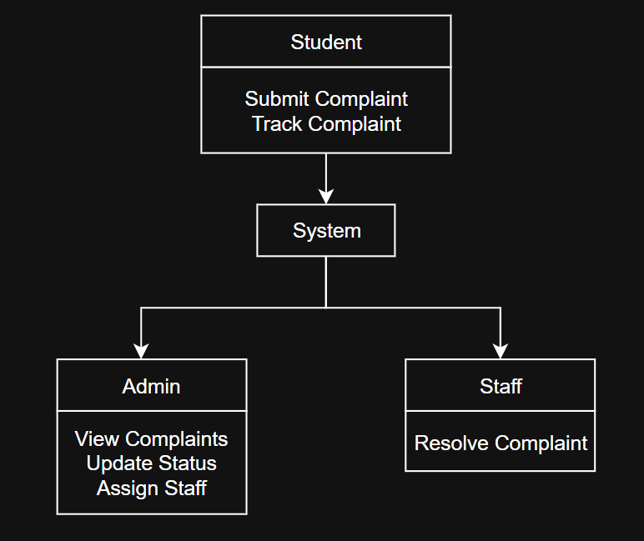

4.2 Data Flow Diagram
